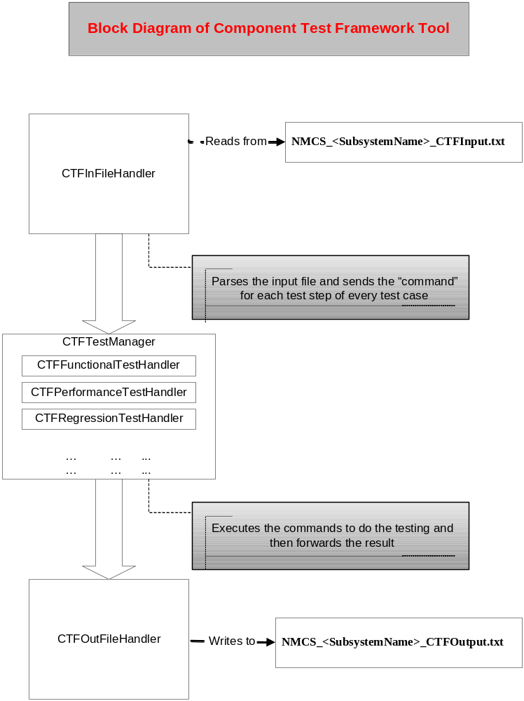

Block diagram of NMCS Component Test Framework Tool
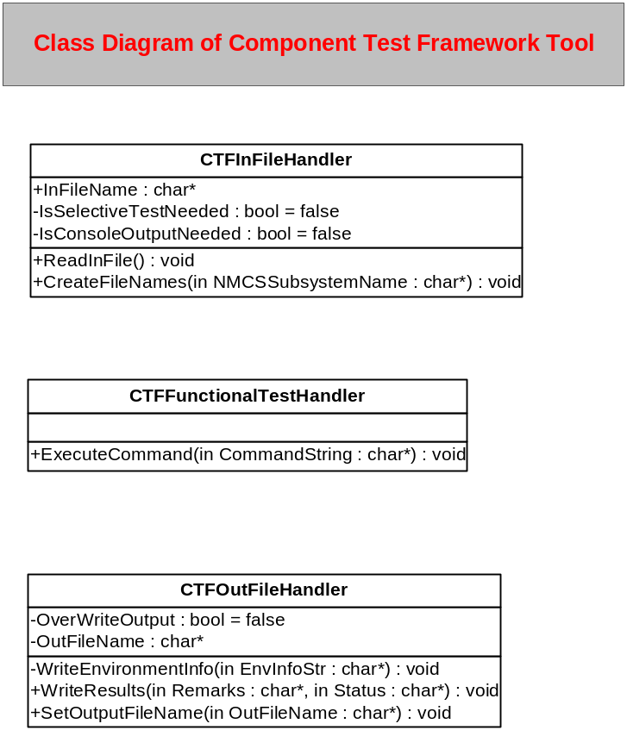

Class diagram of NMCS Component Test Framework Tool

Details of Major Functions:

CTFInFileHandler::ReadInFile()
This function reads the input file (i.e.“NMCS_<SubsystemName>_CTFInput.txt”) and calls the function WriteEnvironmentInfo() to write the Build and version info to o/p file. It calls the ExecuteCommand() to run the various test steps (Commands) related to each test case.

